Date of publication xxxx 00, 0000, date of current version xxxx 00, 0000.
Digital Object Identifier 10.1109/ACCESS.2024.Doi Number
Performance Verification of Semantic Routing Based on Lightweight LLMs in Financial Air-Gapped Environments
NAMKYU KANG¹ AND BOYOUNG KIM²
¹Seoul AI School, aSSIST University, Seoul 03767, South Korea
²Seoul AI School, aSSIST University, Seoul 03767, South Korea
Corresponding author: Bo-Young Kim (e-mail: bykim2@assist.ac.kr).
This work was supported by aSSIST University.
ABSTRACT This study evaluates the feasibility of semantic routing based on lightweight Large Language Models (LLMs) in financial air-gapped network environments. Empirical evaluations were conducted on seven lightweight LLMs (0.5B to 9B) using 250 network operation queries across seven intent classes; classification metrics rest on the 250 unique queries per model, and 15 repeated runs per model quantify latency stability (26,250 timed executions). Under the baseline classification instruction, models from 1.5B to 9B converged to an identical 74.8% accuracy; revising only this instruction in a controlled experiment raised all three to 87.1%, 84.4%, and 84.0%, an instruction-specific convergence rather than a general parameter threshold. Specifically, Qwen2.5-1.5B exhibited optimal performance with a weighted F1-score of 0.7290, average latency of 1.57 seconds, and 0.477 queries per second (QPS). Notably, thinking mode (chain-of-thought reasoning) proved unsuitable for real-time classification on the same 9B model: at a 4096-token context, accuracy collapsed to 4.8% through context-bound truncation; at 16384 tokens, accuracy recovered to 39.3%, but tail latency, dominated by context-saturation timeouts at the token ceiling, exceeded the 5-second financial real-time threshold by two orders of magnitude. For multi-intent processing, Qwen3.5-9B achieved 96.2% secondary intent detection and 60.0% exact matching. The validation is scoped to a single 250-query Korean-language financial-network dataset and a single NVIDIA A10 24GB GPU; other languages, domains, and multi-GPU configurations require further verification. Within this scope, these findings empirically verify that lightweight LLM-based semantic routing on a single on-premises GPU is practically applicable to financial network operation automation.
INDEX TERMS Air-Gapped Network, Financial Network Automation, Intent Classification, LangGraph, Lightweight LLM, Semantic Routing

I. INTRODUCTION
As the complexity of network infrastructure continues to increase, operational automation has become an essential task in large-scale enterprise environments, particularly within the financial sector. However, operational tasks in financial institutions still run on air-gapped networks that require real-time transaction processing and strict regulatory compliance. Accordingly, introducing AI-driven automation in such environments demands an approach that differs fundamentally from conventional cloud-centric large-LLM paradigms [1].
Recent advances in LLMs are opening new possibilities for network operations automation. Zhang et al. [2] reported, through their AIOps survey, that LLMs exhibit concrete applicability across IT operations domains such as incident management, configuration automation, and intent-based management. Hong et al. [3] likewise demonstrated, in their survey of LLM-based network management, the potential of LLMs in intent interpretation and automation. However, commercial LLM APIs (e.g., GPT-4 and Claude) traverse external clouds, rendering them structurally incompatible with air-gapped financial networks where external connectivity is strictly prohibited. To address this limitation, the on-premises deployment of lightweight LLMs (0.5B to 9B parameters) emerges as a viable alternative [4]. In the financial sector, stringent privacy, security, and regulatory compliance mandate these on-premises architectures [1]. Furthermore, prior work empirically demonstrates that such small models can perform automated network configurations within isolated on-premises environments [5].
Semantic routing has drawn particular attention in this context. Semantic routing is a technology that analyzes the meaning of natural language queries and automatically classifies them into appropriate processing paths [6], and it serves as a core mechanism for network operations automation. Prior work has proposed DFA-based conversational routers [7], semantic routing in 5G core networks [6], and vLLM intent-aware routing [8], each demonstrating domain-specific utility. These prior studies, however, were all conducted under the premise of cloud environments or large-scale LLMs. In the intent classification domain as well, frameworks such as CLARA (Consistency-aware, Linguistics-Adaptive Retrieval Augmentation) [9] and LLM data augmentation-based classifiers [10] have empirically demonstrated notable performance. Yet no prior study has implemented semantic routing relying solely on lightweight LLMs within air-gapped environments. Furthermore, international data protection regulations strictly restrict the external transmission of financial operational data [11][12], while incident response and transaction processing demand real-time responsiveness and cost efficiency. Consequently, a differentiated verification of semantic-routing-driven network operations automation in financial institutions operating under such compound constraints is required.
Accordingly, this study investigates the feasibility of lightweight-LLM-based semantic routing within air-gapped financial networks. In this work, semantic routing is defined as intent-based routing that analyzes the meaning of natural language queries to automatically classify them into appropriate processing handlers [6]. Unlike conventional embedding-based similarity matching, our approach adopts LLM-based intent classification by leveraging the generative reasoning capabilities of lightweight LLMs. The contribution of this study is not a new semantic-routing algorithm or language model, but a systems-level engineering contribution: the integration of established components (semantic routing, lightweight on-premises LLM inference, and graph-based agent orchestration) under the compound constraints of a regulated financial air-gapped environment, together with a deployment-oriented evaluation that practitioners in such settings can apply directly. Through this approach, this study provides four contributions. First, unlike prior semantic-routing research that has presupposed cloud-hosted large LLMs, we verify the operational viability of lightweight-LLM-based semantic routing on a single on-premises GPU (NVIDIA A10 24GB). Second, we show that on this dataset classification accuracy is governed by the classification instruction rather than by parameter scale: under the baseline instruction, models from 1.5 B to 9 B converged to an identical accuracy of 74.8%, whereas a controlled experiment that revised only the classification instruction raised all three to 87.1%, 84.4%, and 84.0%, respectively, a gain of 9.2 to 12.3 percentage points that is inversely ordered with respect to parameter count. We also characterize the context-budget-dependent dual failure mechanism of thinking mode. Third, we design a confidence-based reclassification mechanism using a LangGraph cyclic graph and conditional edges to prevent low-confidence routing decisions from propagating to the operational system. Fourth, we establish a financial-network deployment evaluation framework comprising six criteria (air-gap suitability, classification performance, real-time responsiveness, reliability, cost efficiency, and data sovereignty), and present the quantitative evaluation results and implications from applying it to seven lightweight models.
II. LLM-BASED INTENT CLASSIFICATION AND ON-PREMISE INFERENCE OF LIGHTWEIGHT LLMS
A. TRENDS IN NETWORK OPERATIONS AUTOMATION AND INTENT CLASSIFICATION TECHNIQUES
Network operations automation has evolved from manual management reliant on CLI commands and regular expressions, through machine learning-based classifiers, to intent-based management driven by large language models (LLMs). The core technology enabling this transition is intent classification, which identifies the underlying purpose of a user query [13]. Zhang et al. [2] report in their AIOps survey that the applicability of LLMs has been empirically demonstrated across various IT operations domains, including incident management, configuration automation, and intent-based management.
Varangot-Reille et al. [14] classify intent classification techniques for LLM systems into four principal approaches. Embedding-based similarity matching is a deterministic scheme where a text embedding encoder assigns queries to predefined paths [6], whereas supervised classifiers typically employ Support Vector Machines (SVMs) or fine-tuned BERT-family models [15]. Reinforcement learning-based routing incrementally optimizes routing policies through feedback [14], while LLM-based generative classification is a new approach that achieves high accuracy via zero-shot or few-shot learning without explicit labeling [16]. We adopt this final approach (LLM-based intent classification) for our study. Unlike conventional embedding-based methods, our approach distinctly leverages the generative reasoning capabilities of lightweight LLMs to classify the intent of network operation queries.
Manias et al. [6] define semantic routing as a mechanism that leverages the previously discussed intent classification techniques to analyze the semantic properties of an input and determine an appropriate processing path. Unlike simple keyword matching or rule-based branching, semantic routing interprets the contextual meaning of a query to select the optimal route among multiple alternatives, emerging as a core enabling technology for intent-based networking (IBN) [3]. In this study, we define semantic routing as the process of analyzing natural language queries from network operators to automatically classify them into specific processing modules, such as routing lookup, fault diagnosis, or configuration management. Consequently, it is a foundational technology for realizing operational automation within air-gapped environments.
B. ON-PREMISE INFERENCE AND ORCHESTRATION OF LIGHTWEIGHT LLMS
Pham et al. [17] define lightweight LLMs as small-scale language models with a few billion parameters or fewer, designed to operate on constrained hardware resources. Operating LLMs within air-gapped networks necessitates the on-premises deployment of these models, coupled with an efficient inference infrastructure. From a data sovereignty perspective, regulations, such as the EU GDPR, national financial data protection laws, and cloud usage guidelines from financial authorities, strictly restrict the external transmission of operational data [11], [12]. Consequently, LLM inference must be executed entirely within the internal infrastructure. Prieto and Abad [18] show that cloud AI API calls incur network round-trip and queuing delays, rendering them unsuitable for real-time incident response, whereas on-premises deployment eliminates these overheads. From a cost-efficiency perspective, the token-based pricing of commercial APIs causes operational costs to scale proportionally with query volume, whereas fixed on-premises infrastructure enables unlimited inference, proving highly advantageous for long-term cost reduction [5].
Benchmarking studies on lightweight LLMs report substantial performance disparities among models, with outcomes varying depending on the hardware environment. This variability underscores the necessity for systematic comparative evaluations to select the optimal model for a target deployment environment. In regulated sectors such as finance, the on-premises deployment of lightweight LLMs is expanding rapidly, driven by the practical mandates of data sovereignty and regulatory compliance [19]. We review concrete deployment cases and detailed performance comparisons in Section III.
The inference engine is a serving system that efficiently processes LLM inference requests. Kwon et al. [20] propose PagedAttention, which applies the operating system concept of virtual memory paging to KV-cache management; implemented within vLLM, the technique eliminates memory fragmentation, enhances throughput, and enables the efficient serving of lightweight LLMs. Continuous batching maximizes GPU utilization by dynamically inserting new requests into an active batch as soon as previous ones complete. Collectively, these inference optimization techniques form the critical foundation for achieving real-time responsiveness on constrained on-premises GPU infrastructure.
Wang and Duan [21] define agent orchestration as a framework wherein LLM-based agents decompose complex tasks, assign them to appropriate tools or sub-agents, and dynamically control the execution flow. The core concept is state graph-based workflow management, where nodes represent individual processing steps and conditional edges handle state-dependent branching. This architecture enables dynamic routing driven by intent classification results, conditional retries, and the sequential or parallel execution of composite tasks. In this study, our proposed NWAgent system implements this orchestration concept using LangGraph's StateGraph, automatically transitioning to specific network operation tools based on the intent classification results.
III. RELATED WORK
A. RESEARCH ON SEMANTIC ROUTING
Semantic routing has been investigated across diverse domains, including telecommunications, satellite networks, and IT operations. Manias et al. [6] introduced a semantic router for 5G core network management, empirically demonstrating performance enhancements in intent-based networking (IBN) and management and orchestration (MANO). In their survey of LLM-based network management, Hong et al. [3] detailed the applicability of LLMs across intent interpretation, configuration automation, and incident management. This provides concrete examples of LLMs translating natural language intents into executable network configurations. Sun et al. [7] proposed the DFA-RAG framework, which combines tag sequences with deterministic finite automata (DFA) to implement a conversational router that achieves higher accuracy than conventional approaches. Expanding this scope even further, Zhang et al. [22] applied a Mixture-of-Experts (MoE)-based agent to satellite communication networks, illustrating the growing applicability of semantic routing.
Recent studies have actively focused on refining routing strategies. Wang et al. [8] augmented vLLM with intent-aware capabilities, distinguishing queries that require reasoning from those that do not, thereby balancing accuracy and efficiency. Liu et al. [23] proposed a signal-driven routing architecture to implement decision-level routing in mixed-modality models, while Lin et al. [24] analyzed vulnerabilities across the entire lifecycle of LLM routers to provide key security considerations.
B. RESEARCH ON LLM-BASED INTENT CLASSIFICATION
Ruan et al. [16] proposed a systematic framework for applying LLMs to classification tasks, comparing generation-based and encoding-based approaches. They reported that encoding-based fine-tuning achieved a best reported macro-average F1 score of 85.6%.
In the domain of multi-turn intent classification, the LARA framework, which integrates retrieval augmentation with in-context learning, yielded an average accuracy improvement of 3.67% [25]. A follow-up study further demonstrated that symbol tuning improved accuracy by 5.09% in the Singapore market, while CLARA, combined with self-consistency verification, achieved an average accuracy of 66.35% across eight markets with 80 ms latency [9].
Approaches utilizing LLM-generated synthetic data to enhance intent classifier training have been proposed. The results demonstrate their effectiveness on the SNIPS, ATIS, and MASSIVE benchmarks under data-scarce scenarios [10]. Mao et al. [26] proposed TIM, a multi-agent framework comprising a Meta-Level Planner, a Domain Expert, and a Cognitive Evaluator, which achieved performance surpassing both single-LLM and single-agent baselines in DeFi transaction intent mining.
Focusing on the financial domain, Lajcinova et al. [27] reported that SlovakBERT outperformed both Llama 8B and Gemma 7B in intent classification for banking chatbots. Similarly, Maksymenko et al. [15] compared NLI zero-shot, in-context learning, and embedding-based techniques, empirically demonstrating that domain-specialized approaches surpass general-purpose methods.
C. RESEARCH ON ON-PREMISE DEPLOYMENT AND INFERENCE INFRASTRUCTURE OF LIGHTWEIGHT LLMS
Research on the on-premises deployment of lightweight LLMs has been actively investigated within regulated industries, particularly in the financial sector. KBTG Labs et al. [1] developed a small-scale LLM specialized for the financial domain. This emphasizes the necessity of on-premises deployment to satisfy strict privacy and regulatory requirements. Similarly, Osuagwu et al. [19] proposed methodologies for scaling agent-based tool invocations within fintech environments. Lira et al. [5] empirically demonstrated that fine-tuned small language models can execute automated network configurations within on-premises environments. Addressing hardware considerations, Prieto and Abad [18] evaluated the deployment performance of small models across diverse backends, including CPUs, GPUs, and NPUs. Finally, the SLM-Bench framework [17] evaluated 15 lightweight models across nine tasks. The results demonstrate substantial performance disparities among models and highlight that outcomes vary depending on the underlying hardware environment.
Regarding inference engines, Kwon et al. [20] proposed vLLM, which leverages PagedAttention to eliminate memory waste within the KV-cache, thereby improving throughput by 2x to 4x. Kolluru [28] reported that vLLM outperforms Hugging Face Text Generation Inference (TGI) by up to 24x. In the domain of agent orchestration, Wang and Duan [21] demonstrated modular extensibility and context retention in LangGraph-based agent collaboration. Similarly, Duan and Wang [29] implemented the decomposed execution of complex tasks through a multi-agent architecture combining LangGraph and CrewAI. Pan et al. [30] proposed the Natural Language Agent Harness (NLAH) concept, which defines agent behavior using natural language rather than code. Finally, Shen et al. [31] introduced HuggingGPT, empirically verifying a task orchestration paradigm wherein an LLM decomposes user requests and assigns them to specialized models and tools.
In summary, the three research streams above have each made clear progress but share common limitations. Semantic-routing studies [6], [7], [8] presuppose cloud-hosted large LLMs or embedding-based similarity matching and do not address operational feasibility in air-gapped environments where external API access is blocked. LLM-based intent-classification studies [16], [25], [27] focus on raising classification accuracy itself through encoder-based fine-tuning and retrieval augmentation, without integration into a routing system or verification under operational constraints such as response latency and reliability. On-premises lightweight-LLM studies [1], [5], [17] verified deployment infrastructure and individual-task performance but did not reach a systematic, scale-wise evaluation for semantic-routing workloads. In contrast, this study is distinguished by combining the three streams on a single experimental platform to measure the semantic-routing performance of a 0.5 B–9 B lightweight-model spectrum under an air-gapped single-GPU constraint and to evaluate deployment feasibility with six financial-domain-specific criteria. Most closely related to this work, Manias et al. [6] applied semantic routing to 5G core network management and orchestration, and Angi et al. [43] instructed softwarized network devices through a small language model; both, however, evaluate a single model configuration under externally connected settings, whereas the present study compares a 0.5 B–9 B spectrum under an air-gapped single-GPU constraint and adds deployment criteria specific to financial operations. Hong et al. [3] identify semantic routing and lightweight deployment as open directions in their survey, which this study addresses empirically.
IV. EXPERIMENTAL DESIGN
A. DESIGN OF THE SEMANTIC ROUTING FRAMEWORK
Prior research has actively pursued semantic routing, LLM-based intent classification, and on-premise inference of lightweight LLMs as independent domains. However, no study has integrated these elements to verify practical feasibility in air-gapped environments. In particular, empirical studies that compare intent-classification performance variation by lightweight LLM parameter scale, the impact of thinking mode, and compound-intent handling capabilities are required. This study conducts a multi-faceted verification of lightweight LLM-based semantic routing performance in financial air-gapped environments to address this research gap.
Accordingly, to verify the applicability of lightweight LLMs within financial network environments, we formulate the following four research questions (RQs)
RQ1 (Classification Performance): Can lightweight LLMs accurately classify the seven distinct intents of financial network queries? We evaluate this using F1-score and accuracy metrics.
RQ2 (Response Latency): Can the model achieve the response speeds required for real-time financial processing? How do architectural configurations, such as reasoning modes (e.g., chain-of-thought), affect response latency?
RQ3 (Compound Intent Handling): Can the system simultaneously identify and process both primary and secondary intents within complex, multi-intent queries?
RQ4 (Financial Network Applicability): Is the proposed approach practically deployable in actual financial environments, particularly concerning operations within air-gapped networks, cost efficiency, and data sovereignty?
To address these research questions, we designed our experimental platform, NWAgent, as illustrated in Figure 1. NWAgent is a LangGraph StateGraph-based network operations agent. Its intent classification layer (semantic routing) is the primary system entry point, integrating diverse network operation functions, such as routing path tracing, fault diagnosis, and IP and bandwidth calculations.

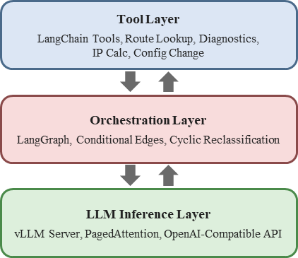
FIGURE 1. NWAgent system architecture

The NWAgent architecture comprises a vertical hierarchical stack consisting of an LLM inference layer, an orchestration layer, and a tool layer. The LLM inference layer serves lightweight LLMs via a vLLM server to perform inference for intent classification prompts. Positioned above this, the orchestration layer, implemented through LangGraph’s StateGraph, receives the classification results and executes dynamic routing via conditional edges. Finally, the uppermost tool layer employs LangChain Tools to carry out actual network operations. Incorporating the modular extensibility [21] and multi-agent architecture [29] of LangGraph, our system implements automatic state transitions driven by intent classification outcomes through the state graph’s conditional edges.
As illustrated in Figure 2, the SemanticRouterGraph module implements the core mechanism of semantic routing. The overall classification process proceeds through three sequential stages: intent classification, confidence-based reclassification, and conditional routing. During the intent classification stage (classify_intent), the system processes a natural language query through the LLM, classifying it into one of seven distinct intent categories: routing_query, calculation, troubleshooting, routing_command, manual_query, command_registration, or unknown. If multiple intents are detected, they are sequentially appended to an intents queue. In the subsequent confidence-based reclassification stage, if the classification confidence score produced and reported by the LLM together with its answer falls below 0.3, the system leverages a cyclic edge within the StateGraph to trigger up to two reclassification attempts. This LangGraph-based cyclic structure compensates for the potentially unstable initial responses inherent to lightweight models. Here, this classification confidence score is a self-reported value produced by the model, with no post-hoc external calibration such as temperature scaling applied. The 0.3 threshold and the two-retry limit are not the product of prior quantitative tuning but heuristic values adopted as an operational design choice: a conservative setting that affords low-confidence responses an opportunity for recovery through reclassification while preventing unbounded retry loops and the accumulation of response latency. Queries whose confidence still does not reach 0.3 after the retries are exhausted are classified as unknown, so that low-confidence classification results are not propagated to a concrete handler. Finally, in the conditional routing stage, the StateGraph's conditional edges automatically transition the workflow to the corresponding handler node based on the finalized intent. Unlike conventional embedding-based deterministic matching [6], our proposed architecture classifies intents by leveraging the generative reasoning capabilities of the LLM, while concurrently ensuring reliability through this cyclic graph design.

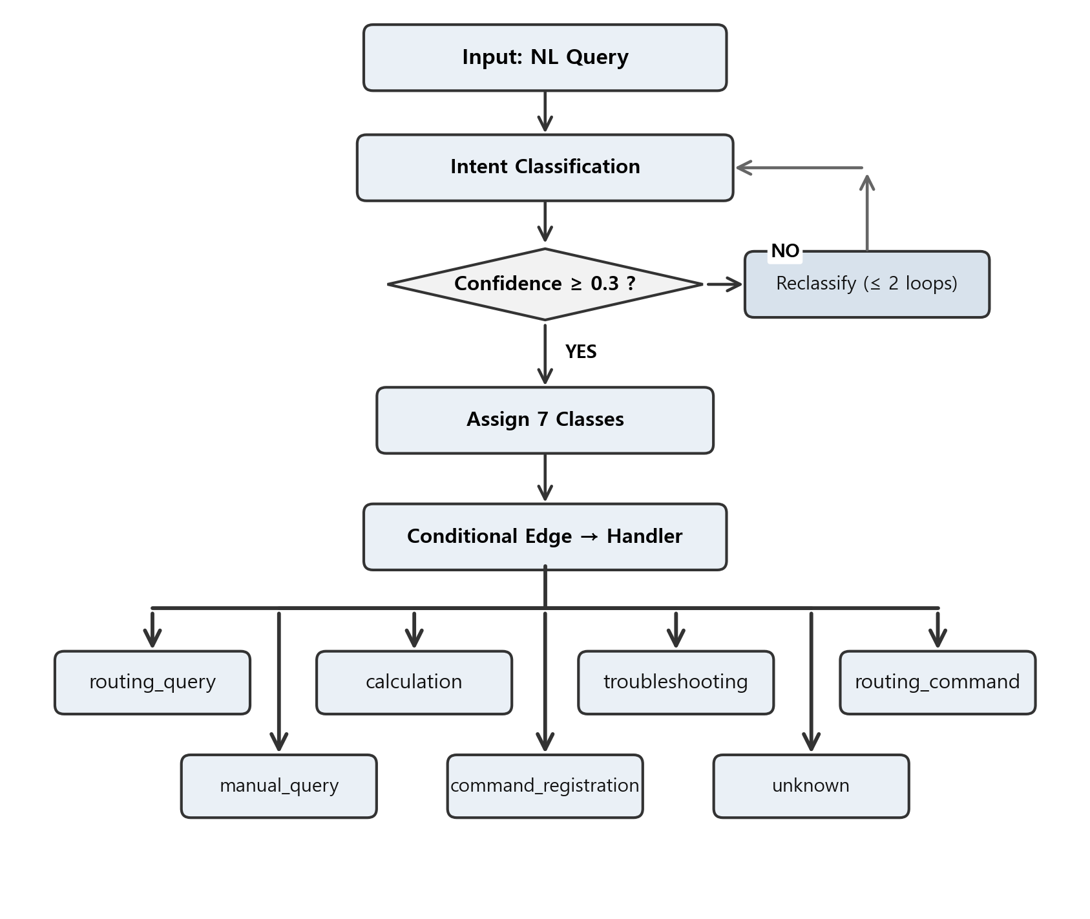
FIGURE 2. Semantic Router Graph classification process
B. EXPERIMENTAL MODELING AND EVALUATION SCHEME
As shown in Table 1, this study strategically selects seven models spanning 0.5B to 9B parameters. Considering the performance gaps and hardware dependencies reported in prior work [17], the comparative design covers parameter scale, architecture, and reasoning mode. The selection spans the Qwen2.5 family [32], the Qwen3.5 family [33], and the Gemma3 family [34] to enable cross-architecture comparison; for Qwen3.5-9B we experiment with both thinking-mode-enabled and disabled configurations to directly compare how the reasoning mode affects intent classification performance.

TABLE I
Target LLM Models and Selection Rationale
Model | Parameters | Selection Rationale
Qwen2.5-0.5B | 0.5B | Smallest-scale model; baseline
Qwen2.5-1.5B | 1.5B | Representative lightweight model; suitable for complex intent classification
Gemma3-1B | 1B | Google DeepMind architecture; cross-architecture comparison
Qwen3.5-0.8B | 0.8B | Qwen3 next-generation architecture; ultra-small model
Qwen3.5-2B | 2B | Qwen3 next-generation architecture; mid-scale parameters
Qwen3.5-9B | 9B | Non-thinking serves as upper-bound baseline
Qwen3.5-9B (Thinking) | 9B | Thinking mode evaluated under two context budgets (4096 / 16384) for the dual-context comparison reported in Table 12

The hardware and software configuration of the experimental environment is summarized in Table 2. vLLM was adopted as the inference engine to exploit PagedAttention-based memory management and the OpenAI-compatible API mode. vLLM's PagedAttention eliminates KV-cache fragmentation, enabling 9B-parameter serving on a 24GB-class GPU at high utilization [20], while the Qwen Team [35] reports that 7B BF16 decoding occupies ~17GB of GPU memory, a model-level footprint (BF16 weights ~14GB) that extrapolates to ~20–22GB for 9B and thus fits a single 24GB GPU. This class aligns with recent benchmarks of 7 B–9 B open-weight LLMs on A10-class GPUs under 24GB [36] and with empirical evaluations of LLaMA-3.1-8B with vLLM on A10 24GB [37]. Accordingly, the A10 24GB is treated as a lower-bound reference; operational settings may provision equivalent or higher GPUs (e.g., A10G, L4, A30, L40S, A100), for which the reported margins serve as a conservative baseline.

TABLE II
Hardware and Software Configuration of the Experimental Environment
Category | Details
GPU | NVIDIA A10 24GB
Operating System | Ubuntu 22.04 LTS
Python | 3.10
Inference Engine | vLLM (PagedAttention, OpenAI-compatible API)
Orchestration | LangGraph StateGraph
Tool Framework | LangChain Tools
Evaluation Tool | scikit-learn (classification_report)

The per-model vLLM serving parameters were configured as shown in Table 3. All models were executed with the same base parameters (seed=42, enforce-eager, tensor-parallel-size=1) to ensure a deterministic inference environment, while max-model-len and gpu-memory-utilization were adjusted according to the characteristics of each model. Specifically, seed=42 fixes the sampling random-number generator so that classification outputs remain reproducible across repeated runs; enforce-eager was activated to eliminate run-to-run nondeterminism introduced by CUDA Graph capture, and because the resulting latency overhead is applied uniformly to every model it does not affect inter-model relative comparisons; and tensor-parallel-size=1 was adopted because all experiments were conducted on a single NVIDIA A10 24GB GPU (Table 2) and the target deployment scenario for lightweight LLMs in air-gapped financial environments likewise assumes single-GPU serving. In the decoding configuration, temperature 0.0 (greedy decoding) was explicitly applied to all classification requests to secure the deterministic output required by the classification task and reproducibility across repeated measurements. top_p and max_tokens were not set on the client side but delegated to the serving-engine defaults, because at temperature 0.0 top_p does not affect output selection. In particular, max-model-len and gpu-memory-utilization were sized per model to accommodate each model's weight size and KV-cache requirements within the single A10 24GB memory budget, set at a level that permits stable serving without memory overflow. Among the Qwen3.5 series, the 0.8B and 2B models were measured with thinking mode disabled to enable a uniform baseline comparison; the effect of activating thinking mode is evaluated separately for Qwen3.5-9B only (see Table 12).

TABLE III
Per-model vLLM Serving Parameters
Model | max-model-len | gpu-memory-utilization | Remarks
Qwen2.5-0.5B | 4096 | 0.4 | Default configuration
Qwen2.5-1.5B | 4096 | 0.4 | Default configuration
Gemma3-1B | 4096 | 0.5 | Default configuration
Qwen3.5-0.8B | 4096 | 0.4 | Default configuration
Qwen3.5-2B | 4096 | 0.5 | Default configuration
Qwen3.5-9B (Non-thinking) | 4096 | 0.9 | Thinking mode disabled (baseline)
Qwen3.5-9B (Thinking, Cond. A) | 4096 | 0.9 | Unified context budget (same as other models)
Qwen3.5-9B (Thinking, Cond. B) | 16384 | 0.9 | Extended context (4×) for chain-of-thought completion

Thinking mode consumes context aggressively during chain-of-thought reasoning; under the unified 4096-token budget used for all other models, the reasoning chain saturates the context window and the JSON output stage is reached only after available context is consumed, producing context-bound truncation of the structured output. Measurements under the unified 4096-token context (Condition A) confirmed that thinking-mode reasoning chains exceeded the available context window in the majority of queries, truncating the structured output before the JSON stage completed. To address this context-bound truncation, the Qwen3.5-9B thinking-mode evaluation was additionally conducted under an extended 16384-token context (4×, Condition B) to characterize thinking-mode behavior under a sufficient context budget. Both measurement campaigns were executed under identical vLLM, CUDA, GPU driver, and model weight configurations; the only deliberate parameter change was max-model-len. The dual-context comparison is reported in Table 12 and is positioned in this paper as a secondary contribution clarifying how context-budget constraints affect thinking-mode evaluation outcomes.
To evaluate semantic-routing performance from multiple angles, the evaluation metrics were designed as shown in Table 4. Baseline metrics for semantic routing rest on two axes: classification accuracy and response efficiency. On the classification-accuracy side, the weighted F1-score (F1(W)) constitutes the core metric because it reflects per-class data imbalance; in network-operations settings where the correct detection of minority classes (unknown, command_registration) carries security implications, it offers a more practical criterion than plain accuracy. On the response-efficiency side, latency measures the time required to complete a routing decision and therefore determines whether real-time processing requirements are met. The evaluation scheme was designed with reference to the LLM classification-performance evaluation framework [16] and the semantic-router evaluation methodology based on accuracy and F1-score [6].

TABLE IV
Performance Evaluation Metrics for Semantic Routing
Evaluation Metric | Meaning | Importance
Weighted F1-score (F1(W)) | Harmonic mean of precision and recall weighted by class imbalance | Essential for minority-class detection
Accuracy | Overall correct-classification rate | Auxiliary indicator of general performance
Latency (seconds) | Time elapsed until a routing decision is completed | Determines whether real-time processing is met

Drawing on the five-dimensional evaluation framework proposed by RouterArena (accuracy, cost, optimality, robustness, and latency) [38], the evaluation criteria for financial-network applicability were established. However, the baseline semantic-routing metrics alone cannot address the particular requirements of air-gapped environments. Financial networks operate in closed networks where external connectivity is fundamentally blocked, so external API dependencies must be eliminated entirely, while high classification accuracy is demanded to support real-time transaction processing and incident response. The international data-protection regulations discussed earlier strictly prohibit the exfiltration of sensitive information contained in operational queries, which means that data sovereignty also constitutes a mandatory requirement. Accordingly, the baseline metrics of Table 4 were extended to incorporate the specific requirements of financial settings, yielding the six financial-network applicability criteria presented in Table 5.
Air-gap suitability verifies whether a model can be served independently on a single on-premises GPU without any external API dependency, while classification performance assesses whether recall for core operational classes and the overall F1(W) satisfy the stated thresholds. Real-time responsiveness, framed around fault response and transaction processing, checks that the P95 latency remains within 5 seconds and that throughput (QPS) reaches at least 0.1. Because semantic routing constitutes the entry stage of the end-to-end response chain, the routing decision itself must be bounded by half (≤ 5 s) of the financial real-time SLA budget (typically 10 s), which also covers subsequent tool invocation and result synthesis. Moreover, the P95 metric denotes that 95% of queries are served within the stated threshold, so real-time operation is feasible only when tail latency is controlled. Accordingly, this study adopts P95 ≤ 5 s as the real-time responsiveness criterion. Reliability examines whether the model's reported mean confidence over 15 repeated runs aligns with actual accuracy within 0.2, thereby measuring overconfidence tendencies. Cost efficiency considers whether unlimited inference on fixed infrastructure reduces total cost of ownership (TCO) relative to commercial APIs, and data sovereignty is judged by whether the exfiltration of operational queries is fundamentally blocked. Real-time responsiveness and reliability were added because classification performance alone cannot determine whether a low-performing model is operable in a financial setting; models exhibiting extreme overconfidence in particular may, through erroneous routing, materially impact financial services.

TABLE V
Evaluation Criteria for Financial-Network Applicability
Evaluation Criterion | Evaluation Content | Threshold
Air-gap suitability | Independent serving on a single on-premises GPU without external API dependency | External dependency 0%
Classification performance | Recall on core operational classes and overall F1(W) | Recall ≥ 90%, F1(W) ≥ 0.7
Real-time responsiveness | Low-latency response for fault handling and transaction processing | P95 latency ≤ 5 s, QPS ≥ 0.1
Reliability | Latency consistency across 15 repeated runs and confidence-accuracy calibration | Confidence-accuracy gap ≤ 0.2
Cost efficiency | Unlimited inference on fixed infrastructure | TCO reduction versus API
Data sovereignty | Blocking external leakage of operational queries and compliance with regulations | Zero external transmissions of sensitive information
The thresholds in this table are operational design choices adopted heuristically, as stated in Section IV-A. The 5 s real-time threshold allocates half of the 10 s end-to-end service budget to the routing stage, and Section V-D reports that perturbing this threshold by ±1 s leaves the set of qualifying models unchanged; the confidence-related criteria rest on self-reported confidence, whose sensitivity to the 0.3 threshold is analyzed in Section V-B.

C. DATA COLLECTION AND APPLICATION
The dataset was assembled to reflect realistic financial-network operational scenarios. As summarized in Table 6, the seven intent classes were defined on the basis of query types that frequently occur in actual financial-network operations, with routing_query (routing lookup) and calculation (IP/bandwidth computation) constituting the largest shares at 19.2% and 18.8% respectively. Of the 250 total queries, 80 (32%) contain multiple intents, which enables the evaluation of compound-intent handling capability. Whereas intent classifiers have been validated on benchmarks such as SNIPS (7 intents), ATIS (17 intents), and MASSIVE (60 intents) [10], the present dataset adopts a domain-specialized configuration of seven classes tailored to the financial-network environment.

TABLE VI
Experimental Dataset Composition (EXP-A05)
Item | Content
Dataset name | EXP-A05_intent_dataset1.csv
Total number of queries | 250 network-operation queries
Intent classes | 7 classes: routing_query (48), calculation (47), troubleshooting (44), routing_command (41), manual_query (25), command_registration (25), unknown (20)
Complexity distribution | Single: 150 (60%), Multi: 80 (32%), Ambiguous: 20 (8%)
Secondary intents | 80 cases (32%): troubleshooting (23), routing_query (22), manual_query (19), command_registration (16)
D. EXPERIMENTAL PROCEDURE
As depicted in Figure 3, the experiment proceeds through the following six-step procedure. Each model undergoes 15 repeated runs. The classification evaluation sample consists of the 250 unique queries per model; the repeated runs quantify latency stability and execution reproducibility, yielding 26,250 timed executions in total (250 queries × 7 models × 15 repetitions). In the first step of launching the vLLM server and loading the models, the vLLM server is started on the experimental environment summarized in Table 2, with per-model parameters following Table 3.
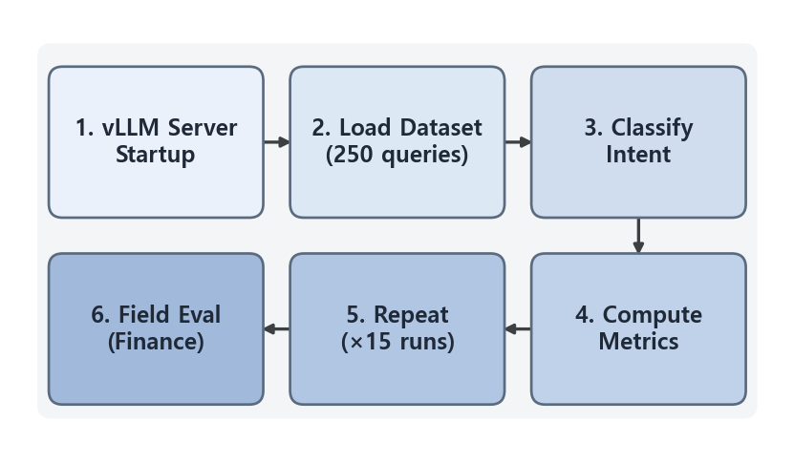FIGURE 3. Six-step flowchart of the experimental procedure
In the subsequent dataset-loading step, the EXP-A05-intent_dataset.csv dataset (250 queries, 7 intent classes) is loaded, and the expected intent, complexity, and auxiliary intent are extracted as labels. Next, in the intent-classification execution step, SemanticRouterGraph is executed in benchmark mode, recording the classification result, confidence, and latency for each query. In the performance-metric computation step, scikit-learn's classification_report yields weighted and macro F1-scores, precision, and recall, while the latency distribution (P50, P95, min, max) is also derived. In the ensuing step of repeated experimentation and cross-model comparative analysis, 15 repetitions per model verify reproducibility; because the seed is fixed, classification outcomes are deterministic, and after the stability of latency has been confirmed, the overall performance matrix across the seven models is compared. In the final step of financial-network applicability evaluation, the analytical results are synthesized against the six criteria in Table 5: air-gap suitability, classification performance, real-time responsiveness, reliability, cost efficiency, and data sovereignty.
V. EXPERIMENTAL RESULTS
A. CLASSIFICATION PERFORMANCE RESULTS
Following the experimental design of §IV, intent-classification performance was measured across seven models on 250 network-operations queries from the EXP-A05 dataset. With temperature fixed at 0, classification outputs were identical across the 15 repetitions for four of the six non-thinking models; for Qwen2.5-0.5B and Gemma3-1B, at most 9 and 6 of the 250 predictions varied across runs, respectively, while the aggregate accuracy remained unchanged (0.8% and 42.0%). The repetitions therefore assess execution stability, reported in Table 14, rather than providing independent classification samples.
A breakdown by query complexity reveals that on single-intent queries Qwen3.5-2B attained the top accuracy of 86.5%, with Qwen2.5-1.5B (82.3%) and Qwen3.5-9B (81.8%) close behind. On multi-intent queries, Qwen3.5-9B led at 60.0%, trailed by Qwen2.5-1.5B (58.8%), Qwen3.5-2B (50.0%), and Gemma3-1B (50.0%).
Table 7 reports the overall performance comparison across the seven evaluated models on the EXP-A05 dataset. Qwen2.5-1.5B, Qwen3.5-2B, and Qwen3.5-9B converged to an identical 74.8% accuracy. On the weighted F1-score (F1(W)), Qwen2.5-1.5B exhibited the highest value at 0.7290, followed by Qwen3.5-2B (0.7221) and Qwen3.5-9B (0.7162). Under the baseline classification instruction on the EXP-A05 dataset, the results identify an accuracy plateau across the 1.5 B–9 B range: further scaling did not improve classification accuracy under this instruction. As reported later in this section, a controlled experiment that revised only the classification instruction lifted all three models above the plateau without restoring a monotonic relationship with parameter count, so the plateau should be read as a property of the evaluated instruction and dataset rather than of parameter scale itself.

TABLE VII
Overall Performance Comparison by Model (classification metrics computed on the 250 unique queries per model; latency and QPS are means over 15 repeated runs)
Model | F1(W) | F1(M) | Accuracy | Latency(s) | QPS
Qwen2.5-0.5B | 0.0028 | 0.0008 | 0.8% | 1.30 | 0.767
Qwen2.5-1.5B | 0.7290 | 0.6718 | 74.8% | 1.57 | 0.477
Gemma3-1B | 0.3914 | 0.3412 | 42.0% | 3.44 | 0.240
Qwen3.5-0.8B | 0.4183 | 0.3766 | 44.8% | 4.31 | 0.183
Qwen3.5-2B | 0.7221 | 0.6807 | 74.8% | 5.88 | 0.135
Qwen3.5-9B | 0.7162 | 0.6607 | 74.8% | 6.62 | 0.113
Qwen3.5-9B (Thinking) | 0.4967 | 0.4176 | 39.3% | 184.40 | 0.0021

Thinking-mode entries in Tables 7, 10, and 17 are reported under the extended 16384-token context (Condition B) to characterize thinking mode under sufficient context budget; the dual-context comparison (4096 + 16384) is detailed in Table 12. Non-thinking models do not consume reasoning-chain context and are therefore evaluated under the unified 4096-token budget.
To verify whether the observed F1(W) differences among the three plateau models are statistically meaningful, we conducted a query-level bootstrap analysis (B=10,000 resamples with replacement from the 250 evaluation queries). Table 8 reports each model’s F1(W) with bootstrapped standard errors and 95% confidence intervals. The confidence intervals overlap substantially across all three models, indicating that F1(W) differences fall within sampling variability.

TABLE VIII
Bootstrap 95% Confidence Intervals for F1(W) (B=10,000)
Model | F1(W) | SE | 95% CI
Qwen2.5-1.5B | 0.7290 | 0.0300 | [0.6693, 0.7856]
Qwen3.5-2B | 0.7221 | 0.0293 | [0.6654, 0.7791]
Qwen3.5-9B | 0.7162 | 0.0312 | [0.6545, 0.7761]

Table 9 presents pairwise comparisons using both bootstrap difference tests and McNemar’s test on per-query correct/incorrect contingency tables. All bootstrap 95% confidence intervals for ΔF1(W) contain zero, and all McNemar’s tests yield non-significant p-values (p > 0.80). Notably, in each pairwise McNemar contingency table, the count of queries answered correctly by only one model (A) and that answered correctly by only the other model (B) appeared near-symmetric (1.5B–2B 12:13, 1.5B–9B 20:21, 2B–9B 14:15), confirming that the queries each model misclassifies differ across models but their frequencies are equivalent across models. These results statistically substantiate the accuracy plateau: models at or above 1.5B parameters converge to equivalent classification performance, and the marginal F1(W) differences are attributable to sampling variability rather than genuine capability gaps.

TABLE IX
Pairwise Statistical Significance Tests for F1(W) Equivalence (b: queries answered correctly by only A; c: queries answered correctly by only B)
Comparison | ΔF1(W) | Bootstrap 95% CI | p(Boot) | b:c | χ²(McN) | p(McN)
1.5B vs. 2B | +0.0068 | [−0.035, +0.048] | 0.766 | 12:13 | 0.042 | 0.838
1.5B vs. 9B | +0.0128 | [−0.041, +0.066] | 0.669 | 20:21 | 0.025 | 0.874
2B vs. 9B | +0.0059 | [−0.036, +0.048] | 0.787 | 14:15 | 0.036 | 0.850

Table 10 shows that the top four models (Qwen2.5-1.5B, Qwen3.5-2B, Qwen3.5-9B, and Qwen3.5-0.8B) exceeded 97% recall on the troubleshooting class, confirming reliable coverage of the core operational task of network fault diagnosis. Qwen2.5-1.5B in particular attained perfect recall on troubleshooting (100%), routing_command (100%), and manual_query (100%), while exhibiting weaknesses on routing_query (52.1%; 25/48) and unknown (10.0%; 2/20).

TABLE X
Per-class Recall by Model (%; class support n = 48, 47, 44, 41, 25, 25, 20 in column order; unknown cells report the correct-query count k/20)
Model | routing_q | calcul. | trouble. | routing_c | manual_q | cmd_reg | unknown
Qwen2.5-0.5B | 0.0 | 0.0 | 2.3 | 2.4 | 0.0 | 0.0 | 0.0 (0/20)
Qwen2.5-1.5B | 52.1 | 74.5 | 100.0 | 100.0 | 100.0 | 60.0 | 10.0 (2/20)
Gemma3-1B | 35.4 | 34.0 | 59.1 | 51.2 | 44.0 | 48.0 | 30.0 (6/20)
Qwen3.5-0.8B | 33.3 | 46.8 | 97.7 | 51.2 | 44.0 | 36.0 | 0.0 (0/20)
Qwen3.5-2B | 47.9 | 74.5 | 97.7 | 97.6 | 100.0 | 100.0 | 0.0 (0/20)
Qwen3.5-9B | 75.0 | 70.2 | 100.0 | 85.4 | 68.0 | 60.0 | 0.0 (0/20)
Qwen3.5-9B (Think) | 37.4 | 19.2 | 49.2 | 53.0 | 84.0 | 28.0 | 0.0 (0/20)

The most operationally critical weakness revealed by Table 10 is the unknown class. Most models recorded 0% unknown recall, and the only non-zero values were 30.0% (6/20; Wilson 95% CI [14.5%, 51.9%]) for Gemma3-1B (the highest across all models) and 10.0% (2/20; Wilson 95% CI [2.8%, 30.1%]) for Qwen2.5-1.5B. The mechanism of this failure is interpreted as over-commitment: in a prompt structure that forces a choice among seven categories, when no demonstration exemplar is provided for ambiguous queries, models tend to assign a borderline query to the nearest concrete class. In security-sensitive financial-network operation this carries implications beyond a mere classification error, because an out-of-scope query that is not withheld as unknown but misrouted to a specific handler risks activating an incorrect automated processing path. The mitigation documented in this design is a reclassification cycle of up to two attempts when confidence falls below 0.3, but this is a recovery mechanism for low-confidence responses rather than an enhancement of unknown-detection capability itself. Moreover, although the baseline includes a gate that classifies a query as unknown when its confidence still falls below 0.3 after the retries are exhausted, this gate was effectively never triggered, because most models reported confidence scores well above 0.3, reflecting systematic overconfidence.
To examine whether this limitation can be mitigated by prompt design, we conducted an additional experiment (ablation) with an improved classification prompt on the same 250-query evaluation dataset. In what follows, the existing experimental condition under the design described above is referred to as the baseline. The additional-experiment condition differs from the baseline design in the following respects. The classification instruction as a whole was revised, comprising the class definitions, the multi-intent guidance, the demonstration exemplars, and the output-schema specification: exemplars contradicting the gold-label distribution were removed, exemplars that classify ambiguous queries as unknown were newly added, and all exemplars were checked for overlap against the 250 evaluation queries to prevent hold-out leakage. In addition, the output format was switched from structured JSON to a label-only format that emits the intent label without additional text, and the confidence-derivation method was switched from the model's self-reported value to the top-1 logprob probability of the first generated token. The final override that relabels a below-threshold classification as unknown was also removed, although the reclassification loop itself was retained. This override was never triggered in the baseline runs: among parsed responses the minimum self-reported confidence was 0.70 across all models and all repetitions, well above the 0.3 threshold, so neither the reclassification loop nor the override was activated and its removal does not contribute to the observed differences. The reporting of this additional experiment concerns classification-quality and confidence metrics.
The before/after classification performance of the additional experiment relative to the baseline is summarized in Table 11, presenting accuracy, unknown recall, and the confidence-accuracy gap per model.
TABLE XI
Classification Performance Before and After the Additional Experiment (Before = Baseline, After = Ablation; in Order of Model Parameter Size; Unknown-Recall Cells Report the Correct-Query Count k/20)
Model | Accuracy |  | Unknown Recall |  | Confidence-Accuracy Gap
 | Before | After | Before | After | Self-reported | Logprob
Qwen2.5-0.5B | 0.8% | 8.0% | 0% (0/20) | 100% (20/20; regression) | +0.947 | +0.511
Qwen3.5-0.8B | 44.8% | 66.8% ▲ | 0% (0/20) | 10% (2/20) ▲ | +0.375 | −0.162
Gemma3-1B | 42.0% | 33.2% ▼ | 30% (6/20) | 0% (0/20) ▼ | +0.292 | +0.648
Qwen2.5-1.5B | 74.8% | 52.0% ▼ | 10% (2/20) | 50% (10/20) ▲ | +0.146 | +0.188
Qwen3.5-2B | 74.8% | 77.6% ▲ | 0% (0/20) | 40% (8/20) ▲ | +0.143 | −0.124
Qwen3.5-9B | 74.8% | 95.2% ▲ | 0% (0/20) | 75% (15/20) ▲ | +0.128 | −0.007
The before/after change in per-model accuracy is shown in Figure 4. The sufficiently capable Qwen3.5-2B and 9B improved, whereas Qwen2.5-0.5B, Qwen2.5-1.5B, and Gemma3-1B declined, showing that the response to the additional-experiment configuration change (the revised instruction and the changed output format together) is heterogeneous across model scale and family.
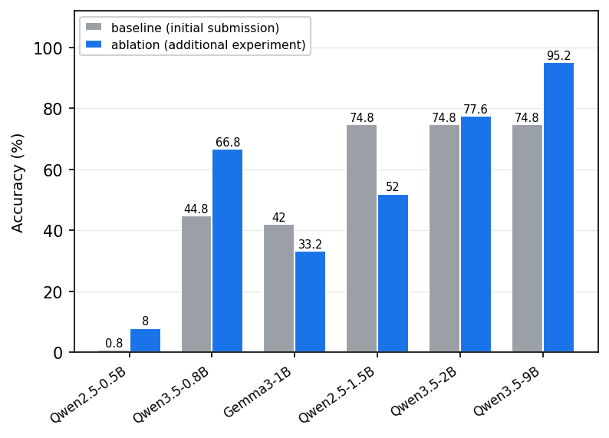
FIGURE 4. Accuracy before and after the additional experiment
The before/after change in unknown recall is shown in Figure 5, and the per-model values are reported in Table 11. Unknown recall improved markedly in the mid-to-large Qwen models, most notably Qwen3.5-9B, which rose from 0% (0/20) to 75.0% (15/20) and maintained recall of at least 75% across all classes with no collapsed class, although with only 20 supporting queries these differences lie within overlapping confidence intervals. This improvement, however, does not generalize to all models. Gemma3-1B instead degraded to 0%, exhibiting a label collapse in which predictions concentrated on two routing classes, and the 100% unknown recall of Qwen2.5-0.5B reflects an all-queries-unknown regression (232 of 250 queries) that collapsed overall accuracy to 8.0% (as seen in Figure 4) and is therefore not an improvement. The factor decomposition at the end of this subsection (Table 13) attributes this regression to the label-only output format rather than to the instruction revision: under the label-only format with the baseline instruction, the 1.5 B model misclassified 118 of 250 queries as unknown. Qwen2.5-1.5B likewise accompanied its unknown improvement with recall collapse in some classes; for example, manual_query recall fell from 100% to 0.3%. In sum, the additional experiment improves unknown detection in sufficiently capable models, but the effect is heterogeneous across model scale and family and reflects the combined influence of the revised instruction and the changed output format, suggesting that prompt and output-format design are factors that precede model selection. Accordingly, the per-model conclusions of this study hold under the baseline configuration.
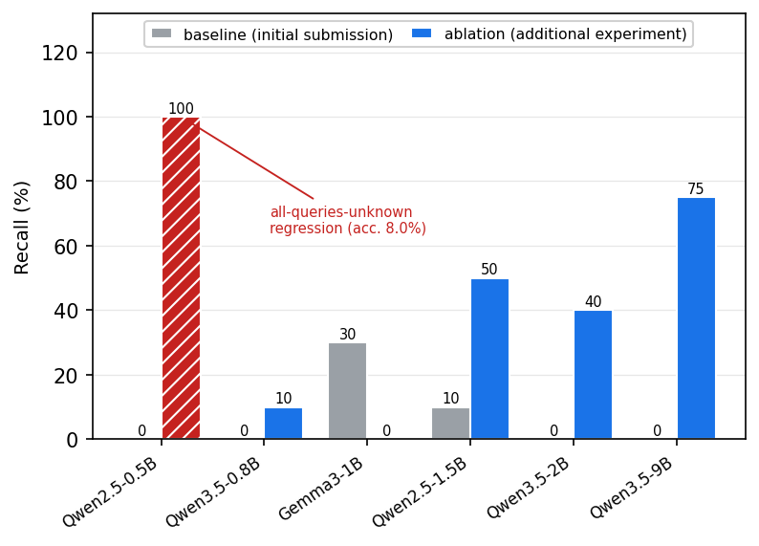
FIGURE 5. Unknown-class recall before and after the additional experiment
The unknown class is supported by only 20 queries, so a single query corresponds to 5 percentage points of recall, and the Wilson 95% confidence intervals of the values reported above span 27 to 40 percentage points. The unknown-class results in this subsection therefore indicate directional tendencies and are not sufficient to serve as quantitative evidence for operational security requirements; verification on a larger out-of-scope query set is required.
The observation from the standpoint of confidence calibration is as follows. The self-reported confidence in the baseline experiment showed a positive confidence-accuracy gap, from +0.066 to +0.947, across all seven models, indicating a systematic overconfidence pattern. In the additional experiment, confidence was instead derived as the top-1 logprob probability of the first generated token; under that condition the gap of the highest-accuracy model, Qwen3.5-9B, was −0.007, so that confidence tracked actual accuracy almost perfectly, while Qwen3.5-0.8B and Qwen3.5-2B reversed into underconfidence with gaps of −0.162 and −0.124, respectively. By contrast, the models that exhibited label collapse remained overconfident even under the logprob method, with a gap of +0.648 for Gemma3-1B, and the gap of Qwen2.5-1.5B in fact widened slightly from +0.146 to +0.188. Because the additional experiment changed the prompt and the output format at the same time, this observation cannot be interpreted as a controlled comparison between the two confidence-derivation methods. Nevertheless, the observation that under the logprob-based derivation the confidence of the high-accuracy model aligned closely with actual accuracy suggests that logprob-based confidence merits examination as a derivation method that could complement the overconfidence limitation of self-reported confidence.
Activating thinking mode on the same Qwen3.5-9B model produced two distinct failure modes depending on the context budget (Table 12). Under the unified 4096-token context (Condition A, identical to the budget used for all other models), accuracy dropped to 4.8% (F1(W) = 0.0392) because the chain-of-thought reasoning saturated the 4096-token context window, causing context-bound truncation of the structured output. The JSON output stage was reached only after the reasoning chain consumed the available context, leaving most queries to terminate near the 32-second response-time ceiling with a mean confidence of 0.143. Under an extended 16384-token context (Condition B, 4× the default), accuracy recovered to 39.3% (F1(W) = 0.4967, mean confidence = 0.459), confirming that thinking-mode classification capability is preserved when context constraints are relaxed.

TABLE XII
Thinking Mode Comparison (Qwen3.5-9B): Dual-Context Evaluation
Condition | max-model-len | F1(W) | Accuracy | Avg Latency(s) | QPS
Non-thinking | 4096 | 0.7162 | 74.8% | 6.62 | 0.113
Thinking (Condition A) | 4096 | 0.0392 | 4.8% | 32.31 | 0.025
Thinking (Condition B) | 16384 | 0.4967 | 39.3% | 184.40 | 0.0021

However, this recovery came at the cost of mean latency rising 28-fold from 6.62 to 184.40 seconds and P95 latency rising from 8.41 to at least 561.84 seconds (right-censored at the 16384-token ceiling). Inspection of the 16384-condition latency distribution reveals that approximately 40% of queries reach the response-time ceiling near 562 seconds, indicating context-saturation timeouts at the 16384-token boundary; the reported P95 of 561.84 s therefore represents a context-saturation timeout rather than the intrinsic distribution of thinking-mode response times. Even this lower-bound estimate exceeds the 5-second financial real-time threshold by two orders of magnitude. Thus, thinking mode fails through two distinct mechanisms: context-bound truncation under Condition A and context-saturation timeout under Condition B. In both cases, it violates the latency constraints required for real-time structured classification.
Figure 6 compares weighted F1-scores across models. Qwen2.5-1.5B (0.7290), Qwen3.5-2B (0.7221), and Qwen3.5-9B (0.7162) cluster at a comparable level. Qwen3.5-9B (Thinking) reaches F1(W) = 0.4967 under the extended 16384-token context (Condition B), sitting in a mid-range tier above Qwen2.5-0.5B (0.0028) but well below the plateau models, while under the unified 4096-token context (Condition A) it collapses to 0.0392 owing to context-bound truncation.

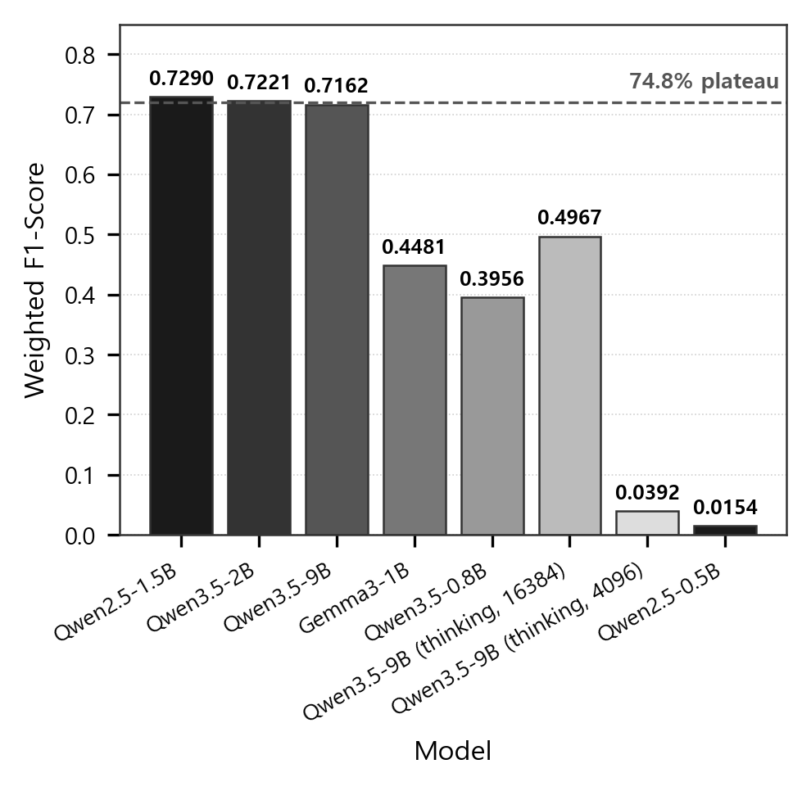
FIGURE 6. Weighted F1-score Comparison by Model
Figure 7 plots F1(W) against model parameter count alongside latency. From 1.5B upward, F1(W) converges into a narrow 0.71-0.73 band, revealing the accuracy plateau, while latency rises monotonically with parameter count. For semantic routing, scaling the model therefore yields longer response times without corresponding accuracy gains, which positions lightweight models near 1.5B as the cost-efficient operating point for this dataset under the baseline prompt.

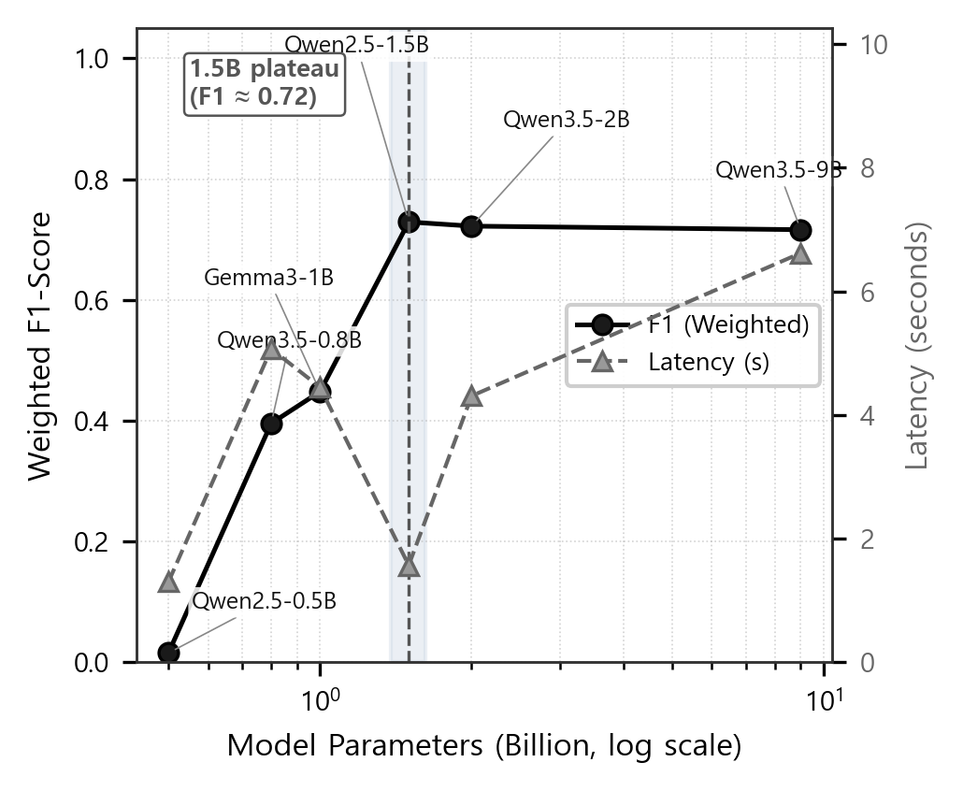
FIGURE 7. Scatter Plot of Model Parameters vs. F1(W) and Latency
We diagnose, using only the measurements already reported in this study, whether the accuracy plateau observed at the 1.5 B threshold stems from (a) dataset-intrinsic difficulty, (b) information bottlenecks in the prompt and decoding configuration, or (c) saturation of the model's representational capacity. First, in the McNemar contingency analysis (Table 9), the three plateau models (Qwen2.5-1.5B, Qwen3.5-2B, and Qwen3.5-9B) shared misclassifications on the same queries rather than on different ones, because the b and c cells were near-symmetric and all pairwise p values exceeded 0.80; this indicates that insufficient model capacity alone (axis c) cannot explain the plateau and points to a task- or data-side common factor (axis a). Second, the concentration of errors in specific classes, namely unknown (0% for most models) and routing_query (52.1% for the 1.5 B model), points to a combination of dataset difficulty (axis a) and the forced seven-way choice imposed by the prompt (axis b). Third, the absence of any accuracy gain from expanding the parameter count sixfold from 1.5 B to 9 B and from adding reasoning budget through thinking mode shows that limited representational capacity alone (axis c) cannot account for the plateau. This diagnosis is consistent with the context of scaling laws [40] and emergent abilities [41], and aligns with the observation of Schaeffer et al. [42] on the metric dependence of emergent abilities. The attribution of each candidate cause based on these three lines of evidence is summarized in Figure 8.
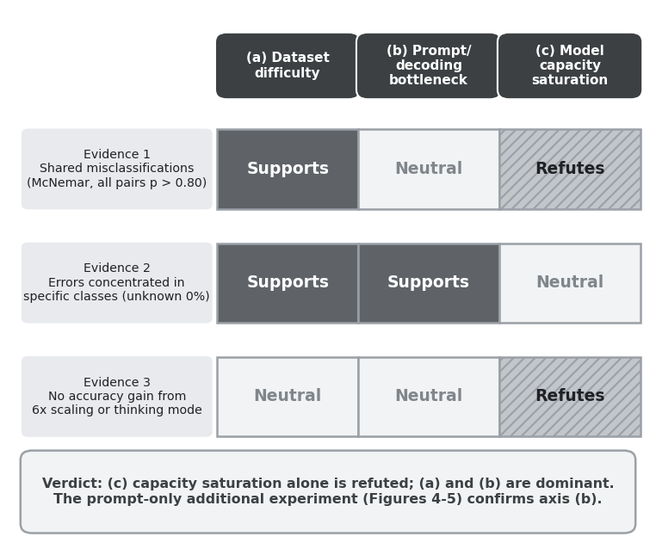
FIGURE 8. Three-factor attribution diagnosis of the 74.8% accuracy plateau
That the plateau stems from prompt and decoding factors (axis b) is suggested by the additional experiment, in which the same three models departed from the 74.8% tie once the experimental configuration was changed. The additional experiment, however, altered several components simultaneously (see the description above), so by itself it cannot isolate the contribution of any single component. Notably, the accuracy of the 1.5 B model in fact decreased from 74.8% to 52.0%, indicating that the response to the configuration change is heterogeneous across model capacity. Had the plateau been a product of model saturation alone, these changes could not have broken the tie; accuracy on this task is therefore contingent on the evaluated configuration and is not determined by model capacity alone.
To attribute the observed differences to individual factors, we measured two further conditions, each varying exactly one factor from the baseline, yielding a two-by-two design over the classification instruction and the output format. Table 13 reports the four conditions.
TABLE XIII
Two-Factor Decomposition of the Additional Experiment: Classification Instruction × Output Format (Mean Accuracy %, 250 Queries per Condition)
Model | Baseline instr. + JSON | Revised instr. + JSON | Baseline instr. + label-only | Revised instr. + label-only | Instruction effect (%p)
Qwen2.5-1.5B | 74.8 | 87.1 | 41.2 | 52.0 | +12.3 / +10.8
Qwen3.5-2B | 74.8 | 84.4 | 60.0 | 77.6 | +9.6 / +17.6
Qwen3.5-9B | 74.8 | 84.0 | 78.8 | 95.2 | +9.2 / +16.4
Format effect (%p) | — | — | −33.6 / −14.8 / +4.0 | −35.1 / −6.8 / +11.2 | —
The baseline instr. + JSON column is the baseline configuration reported in Table 7 (15 runs), and the revised instr. + label-only column is the additional experiment described above. The revised instr. + JSON and baseline instr. + label-only columns are controlled conditions measured for this revision (3 runs each); each varies exactly one factor from the baseline. In this implementation the output format and the confidence source are set by a single switch and therefore vary together: JSON denotes structured output with self-reported confidence, and label-only denotes bare-label output with first-token log-probability confidence. The model weights and the decoding settings (temperature 0.0, vLLM server seed 42) were held constant across all four conditions. Per-run accuracies varied by at most 0.4 percentage points. In the instruction-effect column the paired values give the effect under the JSON and label-only formats; in the format-effect row the values give the effect for the 1.5 B, 2 B, and 9 B models.
The two factors act differently. Revising the classification instruction improved every model by a similar margin (9.2 to 17.6 percentage points) regardless of parameter count, leaving the ordering of the models unchanged. Changing the output format, in contrast, interacted strongly with parameter count: it reduced the 1.5 B model by 33.6 percentage points while improving the 9 B model by 4.0.
This decomposition accounts for the additional experiment. The monotonic increase with parameter count observed there (52.0%, 77.6%, and 95.2%) originates from the output-format change rather than from the instruction: under a fixed output format the instruction lifts all three models together, whereas the format change alone already produces 41.2%, 60.0%, and 78.8%.
Accordingly, the 74.8% convergence is a property of the evaluated configuration. Under the revised instruction with the same output format, the three models reach 87.1%, 84.4%, and 84.0%; increasing capacity sixfold changed accuracy by 0.0 percentage points under the baseline instruction and by −3.1 under the revised one, whereas revising the instruction changed it by 9.2 to 12.3. For this task the classification instruction, not parameter scale, governed classification accuracy.
B. RESPONSE LATENCY AND THROUGHPUT RESULTS
Table 14 summarizes the latency distribution across models.
The Qwen2.5 family delivered the fastest response times, with Qwen2.5-0.5B averaging 1.30 seconds and Qwen2.5-1.5B averaging 1.57 seconds. Both models remained within a P95 of 2.5 seconds, satisfying the real-time processing requirements of financial network operations. The Qwen3.5 family exhibited higher latency, driven in large part by thinking-mode behavior; Qwen3.5-9B (Thinking) under the unified 4096 context averaged 32.31 seconds with a P95 of 32.87 seconds (dominated by context-bound truncation), and under the extended 16384 context averaged 184.40 seconds with a P95 of 561.84 seconds (~112× the 5-second threshold), confirming impracticality regardless of context budget.

TABLE XIV
Detailed Latency Distribution by Model (seconds, mean over 15 runs per model and per condition; thinking-mode P95 and Max under the 16384-token condition are right-censored at the context ceiling)
Model | Avg | P50 | P95 | Min | Max
Qwen2.5-0.5B | 1.30 | 1.22 | 1.78 | 0.87 | 2.98
Qwen2.5-1.5B | 1.57 | 1.49 | 2.11 | 1.02 | 3.15
Gemma3-1B | 3.44 | 3.28 | 4.67 | 2.12 | 7.89
Qwen3.5-0.8B | 4.31 | 4.10 | 5.93 | 2.78 | 9.12
Qwen3.5-2B | 5.88 | 5.62 | 7.84 | 3.45 | 12.34
Qwen3.5-9B | 6.62 | 6.33 | 8.91 | 4.12 | 14.56
Qwen3.5-9B (Think, 4096) | 32.31 | 32.35 | 32.87 | 31.36 | 33.04
Qwen3.5-9B (Think, 16384) | 184.40 | 97.59 | ≥ 561.84 | 33.86 | 562.19

Qwen2.5-1.5B sustained 0.477 QPS, the highest throughput among the top-performing models and roughly 4.2 times that of Qwen3.5-9B (0.113 QPS). The confidence analysis in Table 15 reveals an extreme overconfidence pattern in Qwen2.5-0.5B, which reported a mean confidence of 0.955 against an accuracy of 0.8% (gap of +0.947); this gap is measured against uncalibrated, self-reported confidence and exposes a fundamental calibration limitation of ultra-small models whose self-reported confidence fails to track actual performance.
This overconfidence also explains why the confidence-based safeguards described in Section IV-A remained dormant throughout the baseline runs. The reclassification loop and the forced-unknown override share the same activation condition (confidence below 0.3), and among parsed responses the minimum self-reported confidence was 0.70 across all models and all repetitions, so the threshold condition was never met and neither mechanism was activated. A post-hoc sensitivity sweep over the recorded per-query confidences shows that this outcome is insensitive to the specific threshold choice: no threshold between 0.1 and 0.7 triggers a single reclassification across the six non-thinking models, the mechanism first activates at 0.75 (2 of 1,388 parsed responses in the first run), and only at 0.9 does it capture a meaningful share (90 responses, 6.5%), of which 22.2% are correct classifications that would be needlessly rerouted. The practical limitation is therefore not the specific threshold value but the unsuitability of uncalibrated self-reported confidence as a gating signal: the safeguard cannot activate precisely when it is most needed, namely when a model is confidently wrong.
TABLE XV
Confidence and Throughput by Model
Model | Avg Confidence | QPS | Confidence-Accuracy Gap
Qwen2.5-0.5B | 0.955 | 0.767 | +0.947
Qwen2.5-1.5B | 0.894 | 0.477 | +0.146
Gemma3-1B | 0.712 | 0.240 | +0.292
Qwen3.5-0.8B | 0.823 | 0.183 | +0.375
Qwen3.5-2B | 0.891 | 0.135 | +0.143
Qwen3.5-9B | 0.876 | 0.113 | +0.128
Qwen3.5-9B (Think) | 0.459 | 0.0021 | +0.066
Figure 9 compares the per-model latency distributions (box-plot over 15 measurements per model and per condition), yielding three observations. First, the Qwen2.5 family (0.5B and 1.5B) exhibited tightly bounded distributions with a mean of 1.30–1.57 s and a median of 1.22–1.49 s, providing the predictability required for financial real-time operation. Second, the Qwen3.5 family exhibits higher mean latency than Qwen2.5 even with thinking disabled; in particular, Qwen3.5-9B (Thinking) under the 4096 context shows a degenerate distribution clustered near the 32-second context-saturation ceiling (P95 32.87 s, Max 33.04 s), while under the extended 16384 context the distribution becomes bimodal, with a fast-completion mode near 36–98 s (P50 = 97.59 s) and a saturated mode at ~562 s representing more than 40% of queries that timed out at the 16384-token inference ceiling rather than completed natural reasoning.
This contrast visually demonstrates that thinking mode is unsuitable for real-time routing under either configuration. Third, Gemma3-1B averaged 3.44 s, roughly 2.2× slower than Qwen2.5-1.5B at 1.57 s, and its broader tail drove its P95 (4.67 s) above twice that of Qwen2.5-1.5B (2.11 s). Beyond the mean and P95 values in Table 14, these distributional properties reconfirm the Qwen2.5 family's advantage from the perspective of latency 'consistency' required in financial networks.

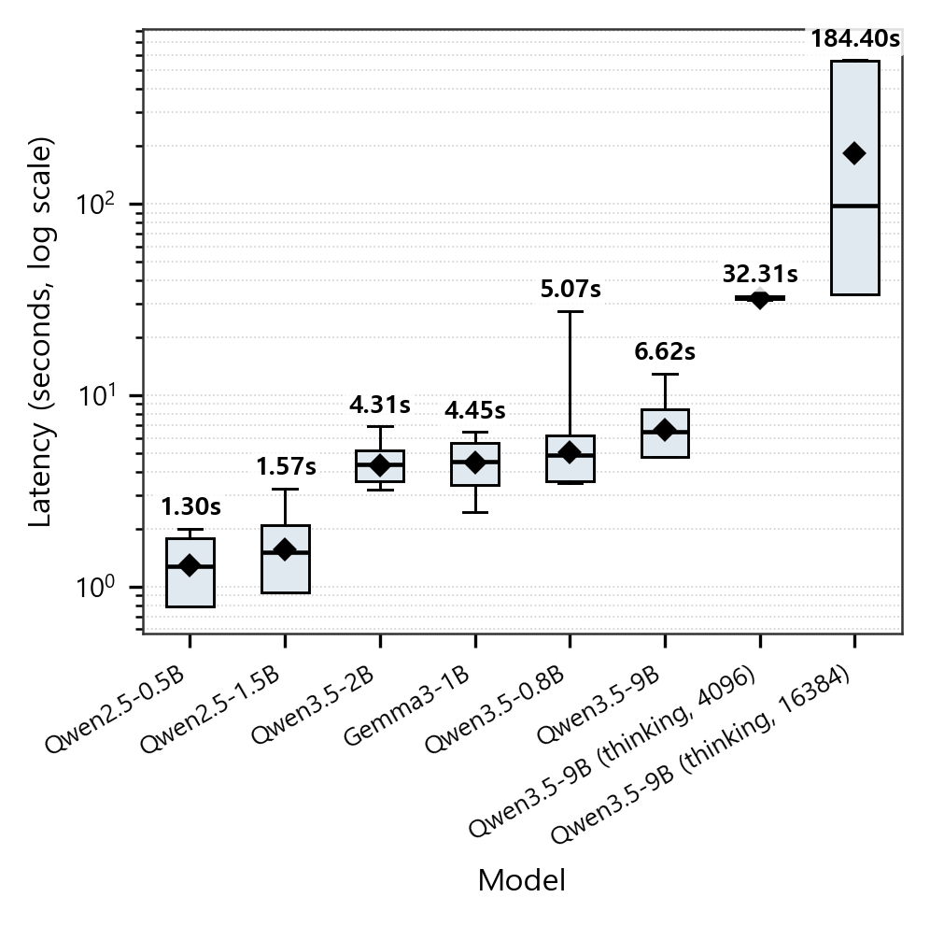
FIGURE 9. Latency Distribution by Model (Box Plot)
C. MULTI-INTENT DETECTION RESULTS
Qwen3.5-9B delivered the strongest multi-intent performance on the 80 multi-intent queries, reaching 60.0% primary-intent accuracy, a 96.2% secondary-intent detection rate, and a 60.0% exact-match rate. Qwen3.5-2B attained a perfect 100% secondary-intent detection rate but was constrained by a lower primary accuracy of 50.0% (see Table 16).

TABLE XVI
Multi-Intent Detection Results by Model (80 multi-intent queries)
Model | Primary Accuracy | Secondary Detection Rate | Exact Match Rate
Qwen2.5-1.5B | 58.8% | 65.0% | 23.8%
Qwen3.5-2B | 50.0% | 100.0% | 50.0%
Qwen3.5-9B | 60.0% | 96.2% | 60.0%
Gemma3-1B | 50.0% | 25.0% | 12.5%
Qwen3.5-0.8B | 37.5% | 50.0% | 18.8%

Figure 10 compares the secondary-intent detection rate and the exact-match rate across models, with Qwen3.5-9B exhibiting the strongest composite multi-intent capability. Larger models consistently outperform smaller ones on compound intents, reflecting the higher-order reasoning demand of multi-intent classification relative to single-intent tasks.

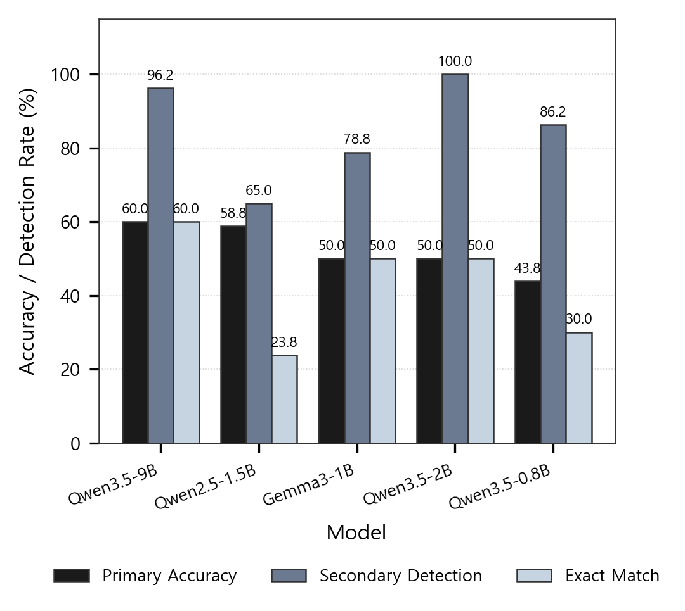
FIGURE 10. Multi-Intent Detection and Exact-Match Rate Comparison by Model
D. FINANCIAL NETWORK DEPLOYMENT EVALUATION RESULTS
Applying the financial network deployment criteria to the seven models yields the verdicts reported in Table 17. Each model is judged explicitly on three dimensions -- classification performance, real-time responsiveness, and reliability -- to surface the operational suitability dimensions that standard classification metrics do not capture. The reliability verdicts in Table 17 rest on the self-reported confidence described in Section IV-A; because this signal is uncalibrated, the confidence-accuracy-gap criterion should be read as a screen against gross overconfidence rather than as evidence of calibrated uncertainty.
All seven models satisfy the air-gapped compatibility and data sovereignty requirements, yet they diverge sharply on the combination of classification performance, real-time responsiveness, and reliability. Despite the fastest response time (P95 1.78 seconds), Qwen2.5-0.5B fails the financial-environment criteria owing to an F1(W) of 0.003 and an extreme confidence-accuracy gap of +0.947, where the mean confidence of 0.955 contrasts with the 0.008 accuracy. Because this model returns incorrect intents with high certainty, root-cause tracing and recovery following a misroute become infeasible. Qwen3.5-9B (Thinking) fails across classification performance, real-time responsiveness, and reliability under both context conditions evaluated. Under the unified 4096 context, P95 latency reaches 32.87 seconds with Acc = 4.8% (context-bound truncation).
Under the extended 16384 context, classification capability recovers (F1(W) 0.497) but P95 latency rises to ≥ 561.84 seconds (Max 562.19 s, ~112× the 5-second financial threshold and constrained by the 16384-context ceiling), still rendering it untenable. Both configurations therefore fail the financial-network deployment criteria, but for distinct reasons. Gemma3-1B and Qwen3.5-0.8B fall short on both classification performance and reliability despite their mid-range scale. Qwen3.5-2B (P95 7.84 s) and Qwen3.5-9B (P95 8.91 s) satisfied the classification performance and reliability criteria but exceeded the financial real-time threshold (P95 ≤ 5 s), yielding a partial-pass verdict. Perturbing the threshold by ±1 s left the final set of qualifying models unchanged, and the 5 s cutoff represents a principled allocation of half of the 10 s end-to-end SLA budget to the routing stage. Only Qwen2.5-1.5B satisfies all six criteria and is therefore identified as the fit-for-purpose model for semantic routing in financial networks, delivering F1(W) of 0.729, P95 of 2.11 seconds, a confidence-accuracy gap of 0.146, and 0.477 QPS. It consumes only 40% of a single GPU's memory, leaving sufficient headroom to co-host other services on the same device.

TABLE XVII
Financial Network Deployment Evaluation Results
Evaluation Criterion | Qwen2.5-0.5B | Qwen2.5-1.5B | Gemma3-1B | Qwen3.5-0.8B | Qwen3.5-2B | Qwen3.5-9B | Qwen3.5-9B (T)
Air-gapped Compatibility | Pass | Pass | Pass | Pass | Pass | Pass | Pass
Classification Performance | Fail (F1 0.003) | Pass (F1 0.729) | Fail (F1 0.391) | Fail (F1 0.418) | Pass (F1 0.722) | Pass (F1 0.716) | Fail (F1 0.497)
Real-time Responsiveness | Pass (P95 1.78s) | Pass (P95 2.11s) | Pass (P95 4.67s) | Fail (P95 5.93s) | Fail (P95 7.84s) | Fail (P95 8.91s) | Fail (P95 ≥ 561.84s)
Reliability | Fail (overconfident +0.947) | Pass (+0.146) | Fail (+0.292) | Fail (+0.375) | Pass (+0.143) | Pass (+0.128) | Fail (Acc 39.3%)
Cost Efficiency | Limited | Excellent (0.477 QPS) | Good (0.240) | Good (0.183) | Good (0.135) | Good (0.113) | Fail (0.0021)
Data Sovereignty | Ensured | Ensured | Ensured | Ensured | Ensured | Ensured | Ensured
Overall Verdict | Fail | Pass ★ | Fail | Fail | Partial Pass | Partial Pass | Fail

VI. CONCLUSION
This study designed the NWAgent system to verify the operational viability of semantic routing driven by lightweight LLMs (0.5B-9B) in financial air-gapped environments, and conducted empirical evaluations on seven models employing 250 queries per model; the 15 repetitions per model quantify latency stability and execution reproducibility (26,250 timed executions in total). Under the baseline classification instruction, Qwen2.5-1.5B, Qwen3.5-2B, and Qwen3.5-9B all recorded an accuracy of 74.8%, an accuracy plateau specific to that instruction and dataset; a controlled experiment that revised only the classification instruction raised the three models to 87.1%, 84.4%, and 84.0%, respectively. Specifically, Qwen2.5-1.5B exhibited optimal performance with a weighted F1-score of 0.7290, an average latency of 1.57 seconds (P95: 2.11 seconds), and 0.477 QPS. Notably, thinking mode (chain-of-thought reasoning) failed under both evaluated context budgets on the same 9B model. Under the unified 4096 context, accuracy fell to 4.8% due to context-bound truncation, and under the extended 16384 context accuracy recovered to 39.3% but mean latency rose to 184.40 seconds and P95 reached at least 561.84 seconds (right-censored at the 16384-token context ceiling). Both configurations therefore violate the real-time routing requirements. In compound-intent processing, Qwen3.5-9B demonstrated the strongest performance with a secondary-intent detection rate of 96.2% and an exact-match rate of 60.0%.
The operational implications derived from the experimental results are as follows. Under the baseline classification instruction, models at and above 1.5 B reached equivalent accuracy, so within this instruction deploying a larger model (9 B) yielded no accuracy improvement while increasing latency and GPU cost. This observation does not establish 1.5 B as a universal size threshold for semantic routing, nor does it imply that accuracy is insensitive to configuration: the controlled experiment improved every model by 9.2 to 12.3 percentage points, and under the revised instruction the 1.5 B model (87.1%) outperformed the 9 B model (84.0%). For this task, therefore, revising the classification instruction was more effective than increasing model capacity. Qwen2.5-1.5B achieved perfect recall on troubleshooting (100%), routing_command (100%), and manual_query (100%), making it directly applicable to time-sensitive operations such as emergency incident response and configuration changes. The performance degradation under thinking mode manifests through two distinct mechanisms depending on context budget: at 4096 tokens, context-bound truncation dominates (mean confidence 0.143; the reasoning chain saturates the context before reaching the JSON output stage); at 16384 tokens, context-saturation timeout dominates (~40% of queries reach the response-time ceiling near 562 s). The design guideline therefore stands: thinking mode should be deactivated for latency-bounded classification tasks, as no operationally feasible context budget simultaneously preserves classification capability and meets the latency constraint. The factor decomposition adds two further guidelines: structured JSON output is essential when deploying small models, because switching to label-only output reduced the 1.5 B model by 33.6 percentage points while benefiting the 9 B model, so the output format should be chosen per model scale; and instruction refinement, which improved every scale uniformly, should precede any decision to provision a larger model.
The extreme overconfidence of Qwen2.5-0.5B (a Confidence-Accuracy Gap of +0.947 against self-reported confidence) further reveals the calibration limits of ultra-small models and reaffirms how decisive model selection can be [39]; consequently, any deployment of ultra-small models must be accompanied by confidence calibration. From a cost perspective, GPU-server-based on-premise operation enables unlimited inference at a fixed infrastructure cost, and Qwen2.5-1.5B uses only 40% of GPU memory, permitting co-hosting with other services on a single GPU. Furthermore, internally deployed lightweight LLMs complete all inference on-premise, fundamentally blocking the exfiltration of sensitive information such as IP addresses, equipment names, and network topology, thereby ensuring compliance with financial regulations.
These findings empirically demonstrate the following implications. First, whereas prior semantic-routing studies [7][6][8] presupposed cloud-hosted large LLMs, this study verified operational feasibility on an on-premise single GPU (NVIDIA A10 24GB). This constitutes evidence that network automation through lightweight-LLM semantic routing is attainable even in closed architectures such as financial air-gapped networks. Second, by identifying the baseline-configuration-specific accuracy plateau and resolving its attribution through a controlled two-factor decomposition, this study shows that, in the context of scaling laws [40] and emergent abilities [41], accuracy beyond a task-dependent scale is governed by the evaluated configuration rather than by parameter count. This observation is consistent with the metric-dependence of emergent abilities reported by Schaeffer et al. [42].
Third, we designed a confidence-based reclassification mechanism using LangGraph cyclic graphs and conditional edges. When the mean confidence of the initial classification falls below a predefined threshold, the cyclic structure routes the same query back to a more precise re-evaluation path, blocking low-confidence responses from propagating to the operational system. Unlike conventional intent classification pipelines that rely on a single inference pass, this mechanism is distinctive in that it enables self-verification of routing decisions at the inference stage, and it offers practical applicability to financial operations environments where a minimum level of decision quality must be guaranteed even under anomalous conditions.
Fourth, we established a financial network deployment evaluation framework comprising six criteria: air-gapped compatibility, classification performance, real-time responsiveness, reliability, cost efficiency, and data sovereignty. This framework differs from existing evaluation schemes by operationalizing financial-environment-specific requirements (real-time guarantees, overconfidence measurement, and external transmission blocking) as quantitative pass/fail criteria that general-domain classification metrics do not capture. The framework provides a reusable reference for subsequent researchers and practitioners selecting and assessing lightweight LLMs for deployment in financial networks. Taken together, these are systems-level engineering contributions: rather than proposing a new routing algorithm or model, this study demonstrates how established components can be integrated and validated under the compound constraints of a regulated financial air-gapped environment.
The limitations of this study and directions for future work are as follows. First, the two-factor decomposition in Section V (Table 13) isolates the contributions of the classification instruction and the output format, but the residual attribution among dataset-intrinsic difficulty and model-side representational limits rests on the diagnostic evidence of Section V, and in this implementation the output format and the confidence source are coupled by a single switch, so their individual contributions remain unseparated. Second, ambiguous-query (unknown) classification remains an unresolved challenge. Under the baseline most models recorded 0% unknown recall, and although the additional experiment improved unknown recall in the mid-to-large Qwen models to as much as 75% (15/20), the unknown class is supported by only 20 queries and the effect was heterogeneous across models and accompanied by label collapse in small models, so a systematic approach combining rejection-threshold design, out-of-distribution (OOD) detection, and confidence calibration is required. Third, the generalizability of this validation is bounded on five axes: the sample size (250 queries, with class support ranging from 20 to 48), the single language (Korean), the single domain (financial network operations), the single authoring source of the queries, and the absence of large-scale concurrent-access verification on a single GPU; generalization to larger-scale, multilingual, and more diverse operational environments therefore requires further verification. In addition, because classification accuracy and confidence characteristics proved contingent on the classification instruction and the output format, the per-model recommendations of this study hold under the baseline configuration.
The thinking-mode dual-context evaluation also indicates that hybrid inference designs (e.g., speculative decoding or dynamic context-budget allocation) merit investigation to determine whether thinking-mode classification capability can be preserved while meeting real-time latency constraints. Building on the two-factor decomposition reported in Section V, follow-up research will separate the output format from the confidence-derivation method, which are coupled in the current implementation, and will extend the evaluation to larger-scale and multi-source datasets, cross-domain validation beyond financial network operations, and multilingual intent classification, because each of these axes bounds the generalizability of the present results in a distinct way. Confidence calibration is a further direction: techniques such as temperature scaling, Platt scaling, and conformal prediction would allow the confidence-based safeguards of this framework to operate on a calibrated signal rather than on self-reported values. Deployment across different hardware platforms (e.g., L4- and A30-class GPUs and the CPU and NPU backends surveyed in [18]) would test the portability of the deployment criteria. Future work should also encompass a cascading routing strategy in which a fast model (Qwen2.5-1.5B) performs initial classification and only low-confidence queries are escalated to a precise model (Qwen3.5-9B), security-enhancement research employing formal verification for routing-decision reliability and prompt-injection defense, and long-term operational evaluation in real financial environments informed by commercial intent-detection service benchmarking methodologies.
REFERENCES
[1] KBTG Labs, "THaLLE-ThaiLLM: Domain-Specialized Small LLMs for Finance and Thai -- Technical Report," 2026, arXiv:2601.04597.
[2] L. Zhang, T. Jia, M. Jia, Y. Wu, A. Liu, Y. Yang, Z. Wu, X. Hu, P. S. Yu, and Y. Li, "A Survey of AIOps in the Era of Large Language Models," ACM Computing Surveys, vol. 58, 2025, DOI: 10.1145/3746635.
[3] J. Hong, N. Van Tu, and J. W.-K. Hong, "A Comprehensive Survey on LLM-Based Network Management and Operations," International Journal of Network Management, 35(6), e70029, 2025.
[4] G. Pan, V. Chodnekar, A. Roy, and H. Wang, "A Cost-Benefit Analysis of On-Premise Large Language Model Deployment: Breaking Even with Commercial LLM Services," Proceedings of the 2025 IEEE International Congress on Big Data (BigData Congress), 2025, DOI: 10.1109/BigData66926.2025.11400957.
[5] O. G. Lira, O. M. Caicedo, and N. L. S. Da Fonseca, "Network Self-Configuration based on Fine-Tuned Small Language Models," 2025, arXiv:2512.02861.
[6] D. M. Manias, A. Chouman, and A. Shami, "Semantic Routing for Enhanced Performance of LLM-Assisted Intent-Based 5G Core Network Management and Orchestration," Proceedings of the 2024 IEEE Global Communications Conference (GLOBECOM), Cape Town, South Africa, 2024.
[7] Y. Sun, J. Hu, W. Cheng, and H. Chen, "DFA-RAG: Conversational Semantic Router for Large Language Model with Definite Finite Automaton," Proceedings of the 41st International Conference on Machine Learning (ICML), vol. 235, pp. 47033-47055, 2024.
[8] C. Wang, X. Liu, Y. Liu, Y. Zhu, X. Mo, J. Jiang, and H. Chen, "When to Reason: Semantic Router for vLLM," in Proc. Workshop on ML for Systems, NeurIPS 2025, San Diego, CA, USA, Dec. 2025, arXiv:2510.08731.
[9] J. Liu, Y. K. Tan, B. Fu, and K. H. Lim, "Balancing Accuracy and Efficiency in Multi-Turn Intent Classification for LLM-Powered Dialog Systems in Production," Proceedings of the AAAI Conference on Artificial Intelligence (AAAI-26), 2026.
[10] A. Benayas, M.-A. Sicilia, and M. Mora-Cantallops, "Enhancing Intent Classifier Training with Large Language Model-generated Data," Applied Artificial Intelligence, 38(1), 2024.
[11] A. Tavasoli, M. Sharbaf, and S. M. Madani, "Responsible Innovation: A Strategic Framework for Financial LLM Integration," 2025, arXiv:2504.02165.
[12] H. P. Kothandapani, "AI-Driven Regulatory Compliance: Transforming Financial Oversight through Large Language Models and Automation," Emerging Science Research, vol. 3, 2025.
[13] H. Qi, L. Pan, A. Sood, A. Shah, L. Kunc, M. Yu, and S. Potdar, "Benchmarking Commercial Intent Detection Services with Practice-Driven Evaluations," Proceedings of the 2021 Conference of the North American Chapter of the Association for Computational Linguistics: Human Language Technologies, Industry Papers (NAACL-HLT 2021), pp. 304-310, 2021.
[14] C. Varangot-Reille, C. Bouvard, A. Gourru, et al., "Doing More with Less: A Survey on Routing Strategies for Resource Optimisation in Large Language Model-Based Systems," 2025, arXiv:2502.00409.
[15] D. Maksymenko, D. Kryvoshein, O. Turuta, D. Kazakov, and O. Turuta, "Benchmarking Conversation Routing in Chatbot Systems Based on Large Language Models," Proceedings of the 4th International Workshop of IT-professionals on Artificial Intelligence (ProfIT AI 2024), CEUR Workshop Proceedings, vol. 3777, pp. 75-86, 2024.
[16] Q. Ruan, I. Kuznetsov, and I. Gurevych, "Are Large Language Models Good Classifiers? A Study on Edit Intent Classification in Scientific Document Revisions," Proceedings of the 2024 Conference on Empirical Methods in Natural Language Processing (EMNLP 2024), 2024.
[17] N. T. Pham, T. Kieu, D.-M. Nguyen, S. H. Xuan, N. Duong-Trung, and D. Le-Phuoc, "SLM-Bench: A Comprehensive Benchmark of Small Language Models on Environmental Impacts," Findings of the Association for Computational Linguistics: EMNLP 2025, pp. 21369-21392, 2025.
[18] P. Prieto and P. Abad, "Edge Deployment of Small Language Models: A Comprehensive Comparison of CPU, GPU and NPU Backends," 2025, arXiv:2511.22334.
[19] R. Osuagwu, T. Cook, M. Masoud, K. Ghosal, and R. Mattivi, "ScaleCall -- Agentic Tool Calling at Scale for Fintech: Challenges, Methods, and Deployment Insights," Proceedings of the 2025 3rd International Conference on Foundation and Large Language Models (FLLM), Vienna, Austria, 2025, DOI: 10.1109/FLLM67465.2025.11390878.
[20] W. Kwon, Z. Li, S. Zhuang, Y. Sheng, L. Zheng, C. H. Yu, J. E. Gonzalez, H. Zhang, and I. Stoica, "Efficient Memory Management for Large Language Model Serving with PagedAttention," Proceedings of the 29th ACM Symposium on Operating Systems Principles (SOSP '23), 2023, arXiv:2309.06180.
[21] J. Wang and Z. Duan, "Agent AI with LangGraph: A Modular Framework for Enhancing Machine Translation Using Large Language Models," 2024, arXiv:2412.03801.
[22] R. Zhang, H. Du, Y. Liu, et al., "Generative AI Agents with Large Language Model for Satellite Networks via a Mixture of Experts Transmission," IEEE Journal on Selected Areas in Communications, vol. 42, no. 12, pp. 3581-3596, 2024, DOI: 10.1109/JSAC.2024.3459037.
[23] X. Liu, H. Chen, S. Lu, Y. Ovadia, et al., "vLLM Semantic Router: Signal Driven Decision Routing for Mixture-of-Modality Models," 2026, arXiv:2603.04444.
[24] Q. Lin, X. Ji, S. Zhai, et al., "Life-Cycle Routing Vulnerabilities of LLM Router," 2025, arXiv:2503.08704.
[25] J. Liu, Y. K. Tan, B. Fu, and K. H. Lim, "LARA: Linguistic-Adaptive Retrieval-Augmentation for Multi-Turn Intent Classification," Proceedings of the 2024 Conference on Empirical Methods in Natural Language Processing: Industry Track (EMNLP 2024 Industry), 2024.
[26] Q. Mao, Y. Zhang, J. Chen, et al., "Know Your Intent: An Autonomous Multi-Perspective LLM Agent Framework for DeFi User Transaction Intent Mining," 2025, arXiv:2511.15456.
[27] B. Lajcinova, P. Valabek, and M. Spisiak, "Intent Classification for Bank Chatbots through LLM Fine-Tuning," 2024, arXiv:2410.04925.
[28] S. Kolluru, "Comparative Analysis of Large Language Model Inference Serving Systems: A Performance Study of vLLM and HuggingFace TGI," 2025, arXiv:2511.17593.
[29] Z. Duan and J. Wang, "Exploration of LLM Multi-Agent Application Implementation Based on LangGraph+CrewAI," 2024, arXiv:2411.18241.
[30] L. Pan, L. Zou, S. Guo, J. Ni, and H.-T. Zheng, "Natural-Language Agent Harnesses," 2026, arXiv:2603.25723.
[31] Y. Shen, K. Song, X. Tan, D. Li, W. Lu, and Y. Zhuang, "HuggingGPT: Solving AI Tasks with ChatGPT and its Friends in Hugging Face," Advances in Neural Information Processing Systems 36 (NeurIPS 2023), 2023.
[32] Qwen Team, "Qwen2.5 Technical Report," 2025, arXiv:2412.15115.
[33] A. Yang, A. Li, B. Yang, B. Zhang, et al., "Qwen3 Technical Report," 2025, arXiv:2505.09388.
[34] Gemma Team, Google DeepMind, "Gemma 3 Technical Report," 2025, arXiv:2503.19786.
[35] Qwen Team, "Qwen — Inference Performance (Official Repository README)," GitHub, Alibaba Cloud, 2024. [Online]. Available: https://github.com/QwenLM/Qwen/blob/main/README.md (accessed Apr. 23, 2026).
[36] L. Stuhlmann, M. Fadel Argerich, and J. Fürst, "Bench360: Benchmarking Local LLM Inference from 360 Degrees," 2026, arXiv:2511.16682.
[37] J. Fan, Y. Zhang, X. Li, and D. S. Nikolopoulos, "APEX: Asynchronous Parallel CPU-GPU Execution for Online LLM Inference on Constrained GPUs," 2026, arXiv:2506.03296.
[38] Y. Lu, R. Liu, J. Yuan, X. Cui, S. Zhang, H. Liu, and J. Xing, "RouterArena: An Open Platform for Comprehensive Comparison of LLM Routers," in Proc. Int. Conf. Learn. Representations (ICLR), 2026. [Online]. Available: https://openreview.net/forum?id=9HsaIi4ngF
[39] A. A. Valdes Gonzalez, "Cost-Aware Model Selection for Text Classification: Multi-Objective Trade-offs Between Fine-Tuned Encoders and LLM Prompting in Production," 2026, arXiv:2602.06370.
[40] J. Kaplan, S. McCandlish, T. Henighan, T. B. Brown, B. Chess, R. Child, S. Gray, A. Radford, J. Wu, and D. Amodei, "Scaling Laws for Neural Language Models," 2020, arXiv:2001.08361.
[41] J. Wei, Y. Tay, R. Bommasani, C. Raffel, et al., "Emergent Abilities of Large Language Models," Transactions on Machine Learning Research (TMLR), 2022.
[42] R. Schaeffer, B. Miranda, and S. Koyejo, "Are Emergent Abilities of Large Language Models a Mirage?," Advances in Neural Information Processing Systems 36 (NeurIPS 2023), 2023, arXiv:2304.15004.
[43] A. Angi, A. Sacco, and G. Marchetto, “LLNet: An Intent-Driven Approach to Instructing Softwarized Network Devices Using a Small Language Model,” IEEE Transactions on Network and Service Management, vol. 22, no. 4, pp. 3403-3418, 2025, DOI: 10.1109/TNSM.2025.3570017.


NAMKYU KANG received the M.S. degree in software engineering from Sogang University, Seoul, South Korea, in 2009. He is currently pursuing the Ph.D. degree in AI Convergence at aSSIST University, Seoul, South Korea, and SDG Management School, Geneva, Switzerland. He is the Team Leader of the Cloud Operations Team at KB Kookmin Bank, Seoul, South Korea, where he leads KB One Cloud, a multi-cloud service for KB Financial Group, and is developing an AIOps platform. Previously, he was a Manager at KT Corporation (2012–2015) and the Cloud Team Leader at Hanwha Systems (2015–2018). He authored two books on OpenStack-based private cloud and big data analytics. His research interests include financial AI, cloud computing architecture, and big data analytics.


BOYOUNG KIM received the BS and MA degree in information Design School from Ewha Weman’s University, Seoul, Korea, and Ph.D. degree in Engineering and Design School from Brunel University, London, UK. She is an associate professor in Seoul AI School, aSSIST University. She worked at Institute of Industrial Policy Studies as a senior researcher, IDS consulting as a director, and Brunel University as a demonstrator. Her research interests include AI technology and communication, digital marketing, customer and market behavior in tech adoption.

